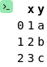
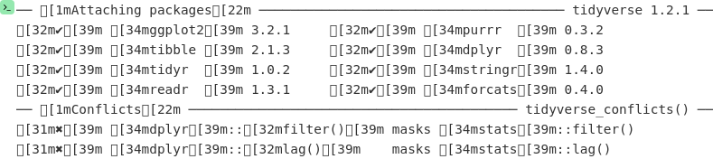
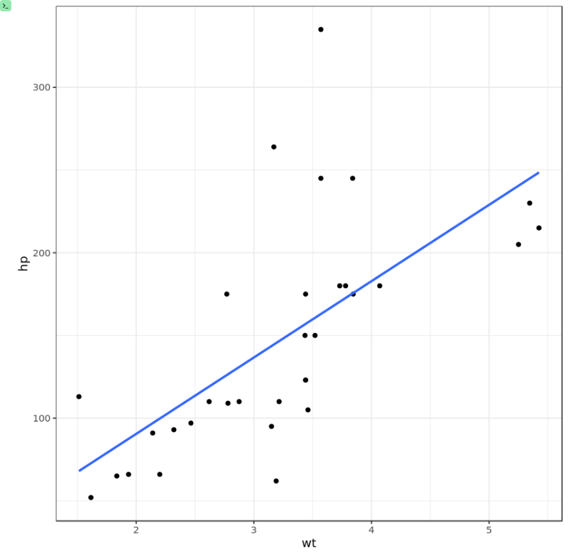
An image won't work. How about some text? This works.
curvenote
Text works, images do not.
Tables do not work either Tables work only under code fence blocks
| x | y |
|----|---|
| 1 | 2 |
